###### A

Mini Project On

#### INTERNAL QR BASED NAVIGATION SYSTEM

(Submitted in partial fulfillment of the requirements for the award of Degree)

BACHELOR OF TECHNOLOGY

In

###### COMPUTER SCIENCE AND ENGINEERING

By

###### GAJULA SANDEEP(197R1A05L0)

###### SRIDASYAM NITHIN (197R1A05P8)

###### POLOJU VENKATESH (197R1A05P2)

Under the Guidance of

**Dr.B.Laxmaiah**

(Associate Professor)



##### DEPARTMENT OF COMPUTER SCIENCE AND ENGINEERING

**CMR TECHNICAL CAMPUS UGC AUTONOMOUS**

(Accredited by NAAC, NBA, Permanently Affiliated to JNTUH, Approved by AICTE, New Delhi) Recognized Under Section 2(f) & 12(B) of the UGCAct.1956, Kandlakoya (V), Medchal Road, Hyderabad-501401.

**2019-2023**

**DEPARTMENT OF COMPUTER SCIENCE AND ENGINEERING**



#### CERTIFICATE

This is to certify that the project entitled **“INTERNAL QR BASED NAVIGATION SYSTEM ”** being submitted by **GAJULA SANDEEP(197R1A05L0), SRIDASYAM NITHIN(197R1A05P8) & POLOJU VENKATYESH(197R1A05P2)** in partial fulfillment of the requirements for the award of the degree of B.Tech in Computer Science and Engineering to the Jawaharlal Nehru Technological University Hyderabad, is a record of bonafide work carried out by them under our guidance and supervision during the year 2022-23.

The results embodied in this thesis have not been submitted to any other University or Institute for the award of any degree or diploma.

**Dr.B. Laxmaiah Dr. A. Raji Reddy**

(Associate Professor) DIRECTOR

INTERNAL GUIDE

**Dr. K. Srujan Raju EXTERNAL EXAMINER**

HOD

**Submitted for viva voice Examination held on**

##### ACKNOWLEDGEMENT

Apart from the efforts of us, the success of any project depends largely on the encouragement and guidelines of many others. We take this opportunity to express our gratitude to the people who have been instrumental in the successful completion of this project.

We take this opportunity to express my profound gratitude and deep regard to my guide **Dr.B.Laxmaiah,** Associate Professor for his exemplary guidance, monitoring and constant encouragement throughout the project work. The blessing, help and guidance given by him shall carry us a long way in the journey of life on which we are about to embark.

We also take this opportunity to express a deep sense of gratitude to the Project Review Committee (PRC) **Dr. Punyaban Patel, Ms. Shilpa, Dr. T . Subha Mastan Rao & J. Narasimharao** for their cordial support, valuable information and guidance, which helped us in completing this task through various stages.

We are also thankful to **Dr. K. Srujan Raju,** Head, Department of Computer Science and Engineering for providing encouragement and support for completing this project successfully.

We are obliged to **Dr. A. Raji Reddy,** Director for being cooperative throughout the course of this project. We also express our sincere gratitude to Sri. **Ch. Gopal Reddy,** Chairman for providing excellent infrastructure and a nice atmosphere throughout the course of this project.

The guidance and support received from all the members of **CMR Technical Campus** who contributed to the completion of the project. We are grateful for their constant support and help.

Finally, we would like to take this opportunity to thank our family for their constant encouragement, without which this assignment would not be completed. We sincerely acknowledge and thank all those who gave support directly and indirectly in the completion of this project.

GAJULA SANDEEP (197R1A05L0)

**SRIDASYAM NITHIN (197R1A05P8)**

**POLOJU VENKATESH (197R1A05P2)**

##### ABSTRACT

We now use Google Maps practically every time we travel to new places because of its ability to guide users to their destinations. However, using Google Maps to navigate in indoor environments such as shopping malls or large college campuses is not viable. To overcome this

limitation, we developed internal qr based navigation system that works in inside locations. There is a growing demand to navigate people not just in the outdoors, but also within facilities

such as hospitals, office buildings, parking garages, and so on. Building navigation systems make people travel not only more efficient, but also safer. People may be navigated to the nearest escape route, and emergency units can operate more efficiently. We used QR codes and a database to guide the user because the GPS units in our phones aren’t accurate enough for indoor navigation. When a QR code is scanned, all of the registered locations with that QR code are displayed to the user, and when the user selects his destination, our application displays directions to that location. This way we can use QR codes in any large indoor locations to help users navigate to their destination easily, this can be used in airports, malls, college campuses, offices and in many other places.

Keywords: QR Code, Database, Navigation, Indoor Environments, GPS.

##### FIGURE NO FIGURE NAME PAGE NO

###### Figure 3.1 Project Architecture for Internal 8

###### QR Based Navigation System .

###### Figure 3.2 Use Case Diagram for Internal 9

###### QR Based Navigation System .

###### Figure 3.3 Class Diagram for Internal 10

###### QR Based Navigation System.

###### Figure 3.4 Sequence diagram for Internal 11

###### QR Based Navigation System.

###### Figure 3.5 Activity diagram for Internal 12

###### QR Based Navigation System .

Figure 6.3.1 Classification of test cases 25

|  |  |  |
| --- | --- | --- |
| **SCREENSHOT NO.** | **SCREENSHOT NAME** | **PAGE NO**. |
| Screenshot 5.1 | User scanning the QR code | 17 |
| Screenshot 5.2 | This page will be shown if the user had scanned a QR code which is not registered | 18 |
| Screenshot 5.3 | Categories displayed to the user for registered qr | 19 |
| Screenshot 5.4 | List of destinations under selected category CSE | 20 |
| Screenshot 5.5 | Application showing directions to the user | 21 |
| Screenshot 5.6 | This page will be displayed if the user had reached the destinations | 22 |

ABSTRACT i

LIST OF FIGURES ii

LIST OF SCREENSHOTS iii

1. INTRODUCTION 1
   1. PROJECT SCOP 1
   2. PROJECT PURPOSE 2
   3. PROJECT FEATURES 2
2. SYSTEM ANALYSIS 3 
   1. PROBLEM DEFINITION 3
   2. EXISTING SYSTEM 3
      1. LIMITATIONS OF THE EXISTING SYSTEM 4
   3. PROPOSED SYSTEM 4
      1. ADVANTAGES OF PROPOSED SYSTEM 5
   4. FEASIBILITY STUDY 5
      1. ECONOMIC FEASIBILITY 5
      2. TECHNICAL FEASIBILITY 6
      3. SOCIAL FEASIBILITY 6
   5. HARDWARE & SOFTWARE REQUIREMENTS 7
      1. HARDWARE REQUIREMENTS 7
      2. SOFTWARE REQUIREMENTS 7
3. ARCHITECTURE 8
   1. PROJECT ARCHITECTURE 8
   2. DESCRIPTION 8
   3. USE CASE DIAGRAM 9
   4. CLASS DIAGRAM 10
   5. SEQUENCE DIAGRAM 11
   6. ACTIVITY DIAGRAM 12
4. IMPLEMENTATION 13
   1. SAMPLE CODE 13
5. RESULTS 17
6. TESTING 23

6.1 INTRODUCTION TO TESTING 23

6.2 TYPES OF TESTING 23

* + 1. UNIT TESTING 23
    2. INTEGRATION TESTING 23
    3. FUNCTIONAL TESTING 24

6.3 TEST CASES 25

* + 1. CLASSIFICATION 25

1. CONCLUSION & FUTURE SCOPE 26
   1. PROJECT CONCLUSION 26
   2. FUTURE SCOPE 26
2. REFERENCES 27
   1. REFERENCES 27
   2. GITHUB LINK 28

# INTRODUCTION

#### 1.INTRODUCTION

##### Indoor positioning and navigation systems are becoming increasingly important as building layouts get more complicated and people become more mobile. Most people find simple floor maps difficult to read, and remaking them when the information on them changes is costly. The databases of Indoor Positioning and Navigation applications are simple to maintain when changes are needed, and almost everyone these days has a smartphone in their pocket. These systems should leverage sensors that are currently found in modern smart phones for high availability. QR (Quick Response) codes give precise location even in interior environments when other navigation systems (such as GPS) are not available. Along with rapidly increasing cities, indoor infrastructures such as malls and airports are expanding at an unprecedented rate. Google Maps on our phones can help us navigate in cities, but it cannot help us navigate inside buildings. And navigating inside a large airport or shopping mall is not an easy task for a mall visitor. To solve this gap, we developed indoor-location-based navigation mobile application

##### 1.1 PROJECT SCOPE

This project is titled “INTERNAL QR BASED NAVIGATION SYSTEM”. The main scope of the project is to find the indoor locations.Nowadays indoor positioning and navigation systems are becoming increasingly important as building layouts get complicated to overcome this problem we had developed an android application to find the indoor locations in large buildings,hospitals,shopping malls. Indoor navigation systems can go beyond simple directions when implementing other technologies that enhance the passenger and employee airport experience. It is important to utilize indoor navigation in airports as it can increase efficiency and drive foot traffic.

##### 

##### 1.2 PROJECT PURPOSE

This project has been developed to identify the indoor locations using qr based navigation system. The main purpose of the project is to overcome the large building navigation system.Along with rapidly increasing cities,indoor infrastructures such as malls and airports are expanding at an unprecedented rate. Indoor navigation is being used more and more by administrative, educational, and medical institutions. Many of them use QR code navigation [integrated into mobile apps](https://navigine.com/developers/" \o "Indoor positioning & Navigation software" \t "https://navigine.com/blog/indoor-navigation-using-qr-codes/_blank). For example, whenever an organization has to control equipment, products, or staff, navigation using QR codes comes into play. Now, you can manage workflows using full movement analytics for each object, as well as create optimal routes for staff.

##### 

##### 1.3 PROJECT FEATURES

The main features of this project are it overcomes the complications in finding the indoor locations.Google maps on our phones on our phones can help us navigate in cities, but it cannot help us navigate in inside building.To solve this gap we had developed internal qr based navigation system android application..

## 2.SYSTEM ANALYSIS

##### 2. SYSTEM ANALYSIS

System Analysis is the important phase in the system development process. The System is studied to the minute details and analyzed. The system analyst plays an important role of an interrogator and dwells deep into the working of the present system. In analysis, a detailed study of these operations performed by the system and their relationships within and outside the system is done. A key question considered here is, “what must be done to solve the problem?” The system is viewed as a whole and the inputs to the system are identified. Once analysis is completed the analyst has a firm understanding of what is to be done.

##### 

##### 2.1 PROBLEM DEFINITION

When you want to go to any place in outdoors, with the help of GPS systems it is a piece of cake, but when you want to go to a particular point in indoor environments such as large shopping malls or college campuses it is a tedious task. Navigating in large indoor environments is the problem we have solved in this project.Indoor Navigation System with QR Codes is a system that allows visitors (who are new to a building where the system is installed) to simply travel to their destination.

**2.2 EXISTING SYSTEM**

Existing systems such as Google maps are helpful to navigate a user from one place to other place outdoors, but it cannot navigate a user in indoor environments. Generally, maps can too accurately locate a user up to 20 meters and this accuracy decreases significantly in indoors as it is using GPS modules present in our mobile phones. Even though in maps application you can see floors and see where a particular outlet is located, maps cannot navigate the user inside the building because of low GPS accuracy.

2.2.1 LIMITATIONS OF EXISTING SYSTEM

Following are the disadvantages of existing system:

* Existing system such as Google maps are helpful to navigate to user from one place to another place outdoors, but it cannot navigate a user in indoor environments.
* Maps can too accurately locate a user up to 20 meters and this accuracy decreases significantly in indoors as it is using GPS module present in our mobile phones
* If the camera quality of the device is not clear then it will become difficult to scan the QR code.

##### 2.3 PROPOSED SYSTEM

Because we cannot use GPS modules in our mobile phones due its low accuracy in indoor environments, our proposed system uses QR codes to navigate the user in indoor environments. Outdoor navigation has become a piece of cake in today’s world because to the widespread usage of GPS technology (Global Positioning System). However, because GPS requires a straight line of sight to the satellite, these applications do not meet the demands of interior navigation. Indoor navigation systems for various infrastructures have been attempted several times. As students, we believe that when new students enroll in college, they have no idea ”What is where?” within the facility. The primary concept behind the app’s development is the annoyance of a user trying to reach their destination on their own in an unfamiliar infrastructure. As a result, we propose to create a system for our college campus buildings that requires pasting QR codes at certain spots around the facility. By scanning the QR Code, this would aid in detecting the current user’s location and, as a result, navigation within the building. This can be done by manually uploading data like distance and directions from one place to other into our Firebase database. This is how it works, at the entrance of the shopping mall or a college campus user should scan the QR code, then user can see a list containing types of destinations that are available at. When user clicks on a category, then user can see all the destinations in that category. Now, when the user clicks on his destination, our application will open phone’s camera and shows direction to the user

2.3.1 ADVANTAGES OF THE PROPOSED SYSTEM

* It is mainly used in large scale buildings.
* It is very useful to navigate to the destination accurately and safely.
* By using QR codes we can retrieve informatiom quickly.

##### 2.4 FEASIBILITY STUDY

The feasibility of the project is analyzed in this phase and a business proposal is put forth with a very general plan for the project and some cost estimates. During system analysis the feasibility study of the proposed system is to be carried out. This is to ensure that the proposed system is not a burden to the company. Three key considerations involved in the feasibility analysis:

* Economic Feasibility
* Technical Feasibility
* Social Feasibility

2.4.1 ECONOMIC FEASIBILITY

The developing system must be justified by cost and benefit. Criteria to ensure that effort is concentrated on a project, which will give best, return at the earliest. One of the factors, which affect the development of a new system, is the cost it would require.The following are some of the important financial questions asked during preliminary investigation:

* + - * The costs conduct a full system investigation.
      * The cost of the hardware and software.
      * The benefits in the form of reduced costs or fewer costly errors.

Since the system is developed as part of project work, there is no manual cost to spend for the proposed system. Also all the resources are already available, it give an indication that the system is economically possible for development.

2.4.2 TECHNICAL FEASIBILITY

This study is carried out to check the technical feasibility, that is, the technical requirements of the system. Any system developed must not have a high demand on the available technical resources. The developed system must have a modest requirement, as only minimal or null changes are required for implementing this system.

2.4.3 SOCIAL FEASIBILITY

This includes the following questions:

* Is there sufficient support for the users?
* Will the proposed system cause harm?

The project would be beneficial because it satisfies the objectives when developed and installed. All behavioral aspects are considered carefully and conclude that the project is behaviorally feasible

##### 2.5 HARDWARE & SOFTWARE REQUIREMENTS

2.5.1 HARDWARE REQUIREMENTS:

Hardware interfaces specify the logical characteristics of each interface between the software product and the hardware components of the system. The following are some hardware requirements.

* + - * Processor : Intel Dual Core I5 and above
      * Hard disk : 8GB and above
      * RAM : 8GB and above
      * Input devices : Keyboard, mouse,camera.

##### 2.5.2 SOFTWARE REQUIREMENTS:

Software Requirements specifies the logical characteristics of each interface and software components of the system. The following are some software requirements,

* Operating system : Windows 8 and above
* Languages : java, xml
* Tools: android studios with version 5.0
* Must have Android Studio IDE installed.

## ARCHITECTURE

##### 3.ARCHITECTURE

##### 3.1 PROJECT ARCHITECTURE

This project architecture shows the procedure followed for classification, starting from input to final prediction.

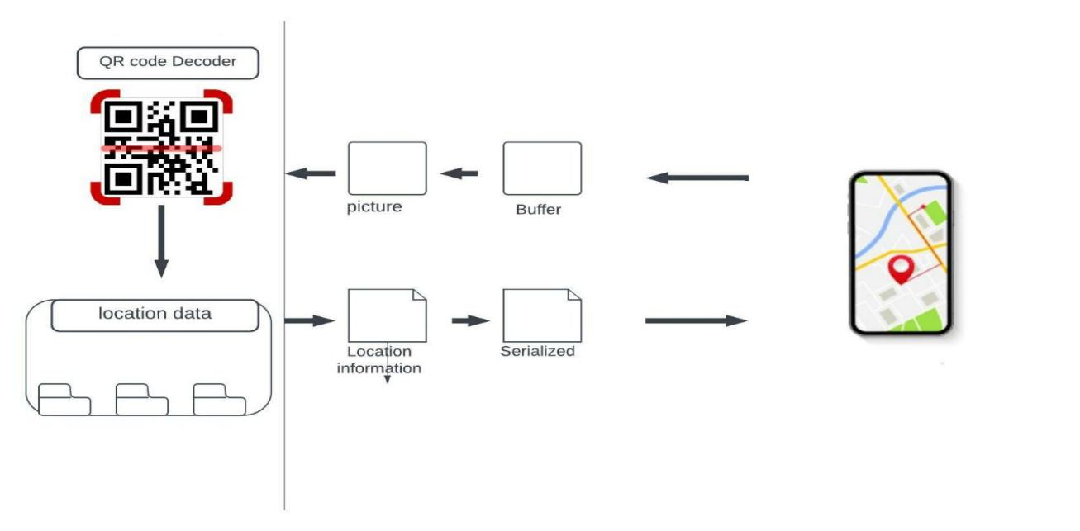

Figure 3.1 Project Architecture of Internal Qr Based Navigation System.

3.2 DESCRIPTION

This project is totally based upon to find the indoor locations.when the user scans the Qr code .It decodes the qr code and find the location data.If the qr code is registered.It retrives the location information and serialize the data and sends the information to the user.user can find the location. If the qr is not registered.It displays the qr is not registered please scan again after 5 sec.This can be done through android studios.

3.3 USE CASE DIAGRAM

In the use case diagram, we have basically one actor who is the user in the trained model.

A use case diagram is a graphical depiction of a user's possible interactions with a system. A use case diagram shows various use cases and different types of users the system has. The use cases are represented by either circles or ellipses. The actors are often shown as stick figures.

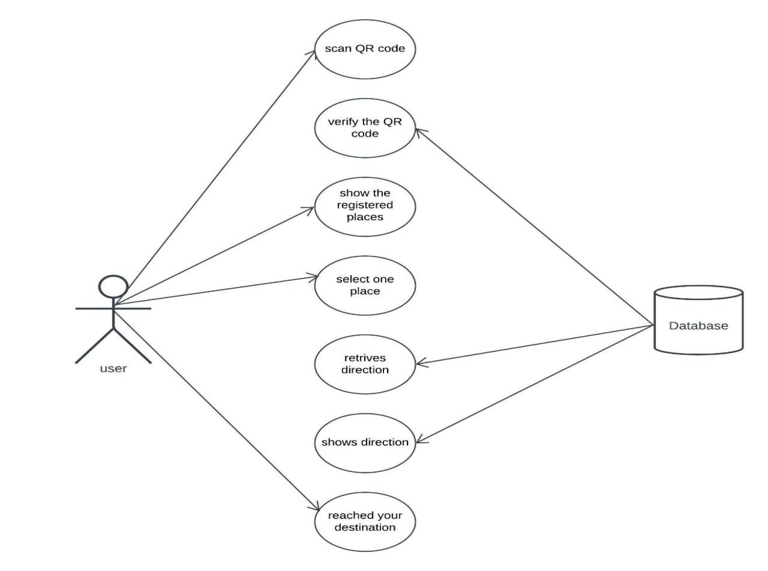

Figure 3.2 Use Case Diagram for Internal Qr Based Navigation System.

##### 3.4 CLASS DIAGRAM

Class diagram is a type of static structure diagram that describes the structure of a system by showing the system’s classes, their attributes, operations(or methods), and the relationships among objects.

s

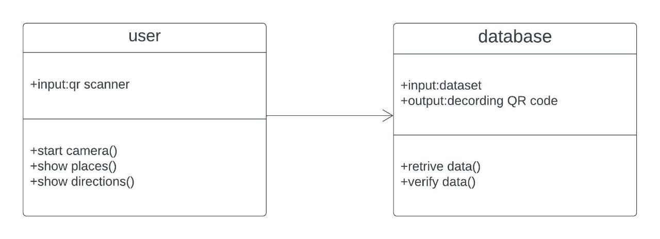

Figure 3.3 Class Diagram for Internal Qr Based Navigation System.

##### SEQUENCE DIAGRAM

A sequence diagram shows object interactions arranged in time sequence. It depicts the objects involved in the scenario and the sequence of messages exchanged between the objects needed to carry out the functionality of the scenario. Sequence diagrams are typically associated with use case realizations in the logical view of the system under development.

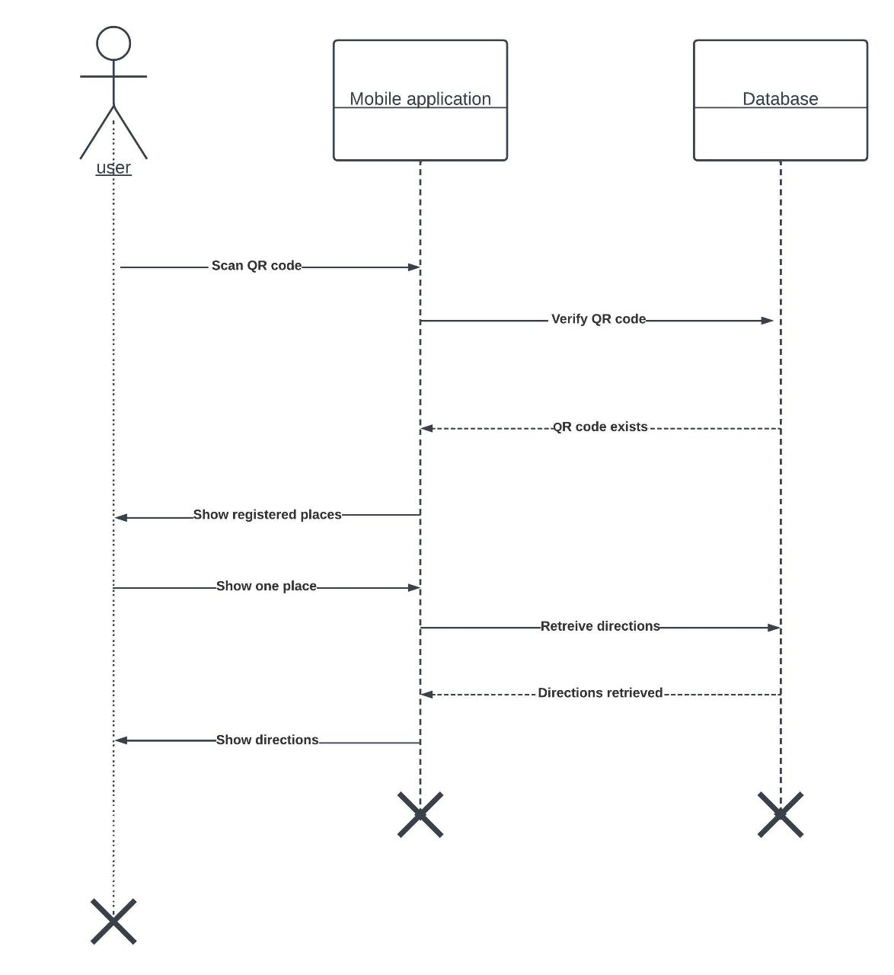

Figure 3.4 Sequence Diagram for Internal Qr Based Navigation System

3.6 ACTIVITY DIAGRAM

Activity diagrams are graphical representations of workflows of stepwise activities and actions with support for choice, iteration and concurrency. They can also include elements showing the flow of data between activities through one or more data stores.

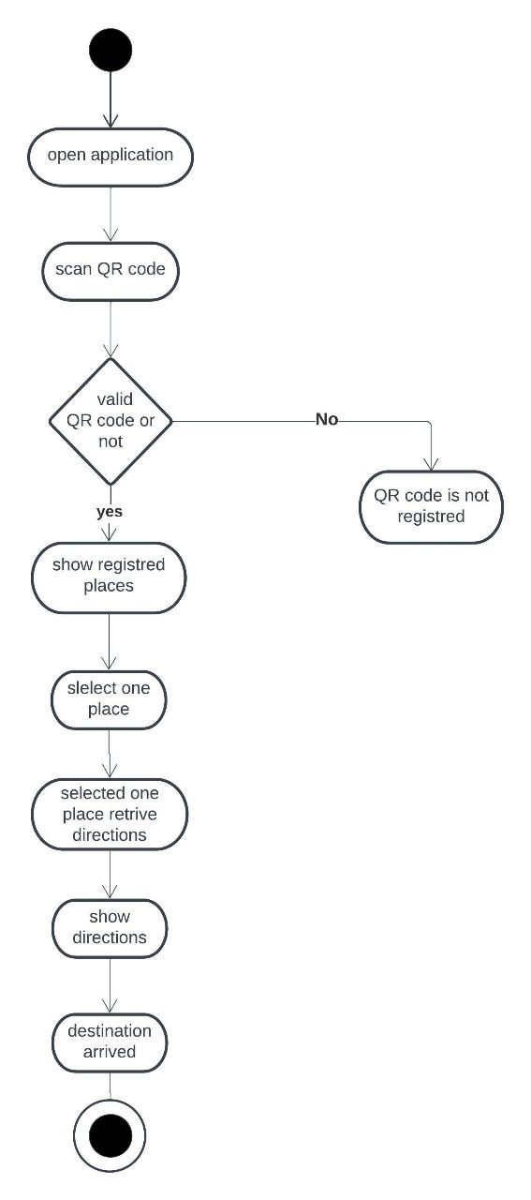

Figure 3.5 Activity Diagram for Internal Qr Based Navigation System.

## 4.IMPLEMENTATION

##### 

##### 4.1 SAMPLE CODE

import android.widget.Toast;

import com.budiyev.android.codescanner.CodeScanner;

import com.budiyev.android.codescanner.CodeScannerView;

import com.budiyev.android.codescanner.DecodeCallback;

import com.google.firebase.database.DataSnapshot;

import com.google.firebase.database.DatabaseError;

import com.google.firebase.database.DatabaseReference;

import com.google.firebase.database.FirebaseDatabase;

import com.google.firebase.database.ValueEventListener;

import com.google.zxing.Result;

import com.surya.indoolocationbasednavigation.databinding.ActivityMainBinding;

import java.util.ArrayList;

import java.util.Map;

public class MainActivity extends AppCompatActivity implements View.OnClickListener {

private CodeScanner mCodeScanner;

String StartPos,Categories,cat1,cat2,cat3,dist_var,var;

Button Button1,Button2,Button3;

ActivityMainBinding binding;

GridLayout categories,Scanner;

TextView dummy;

ListView list;

CodeScannerView scannerView;

String[] distances = new String[100];

String[][] directions = new String[100][100];

String[] destinations = new String[100];

@Override

protected void onCreate(Bundle savedInstanceState) {

super.onCreate(savedInstanceState);

setContentView(R.layout.activity_main);

scannerView = findViewById(R.id.scanner_view);

mCodeScanner = new CodeScanner(this, scannerView);

mCodeScanner.setDecodeCallback(new DecodeCallback() {

@Override

public void onDecoded(@NonNull final Result result) {

runOnUiThread(new Runnable() {

@Override

public void run() {

StartPos = result.getText();

Intent intent = new Intent(MainActivity.this,MainActivity2.class);

intent.putExtra("Startposi",StartPos);

startActivity(intent);

}

});

}

});

scannerView.setOnClickListener(new View.OnClickListener() {

@Override

public void onClick(View view) {

mCodeScanner.startPreview();

}

});

}

@Override

protected void onResume() {

super.onResume();

mCodeScanner.startPreview();

}

@Override

protected void onPause() {

mCodeScanner.releaseResources();

super.onPause();

}

public void displaycategories(){

categories.setVisibility(View.VISIBLE);

FirebaseDatabase database = FirebaseDatabase.getInstance();

DatabaseReference myRef = database.getReference("Message").child("Categories");

myRef.addValueEventListener(new ValueEventListener() {

@Override

public void onDataChange(DataSnapshot dataSnapshot) {

Map<String, Object> Categories = (Map<String, Object>) dataSnapshot.getValue

String[] key = Categories.keySet().toArray(new String[Categories.keySet().size()]);

Button1.setText(key[0]);

Button2.setText(key[1]);

Button3.setText(key[2]);

}

@Override

public void onCancelled(DatabaseError error) {

// Failed to read value

Toast.makeText(MainActivity.this, "Failed to read value.", Toast.LENGTH_LONG).show();

}

});

Toast.makeText(MainActivity.this, "" + Categories,Toast.LENGTH_LONG).show();

cat1 = Button1.getText().toString();

cat2 = Button2.getText().toString();

cat3 = Button3.getText().toString();

}

@Override

public void onClick(View v) {

FirebaseDatabase database = FirebaseDatabase.getInstance();

switch (v.getId()){

case R.id.cat1

final String[] Name = new String[1];

var = Button1.getText().toString();

Toast.makeText(MainActivity.this,""+var,Toast.LENGTH_LONG).show();

DatabaseReference myRef = database.getReference("Message").child("Categories").child(var);

DatabaseReferencemyRef2database.getReference("Message").child("Dist_Direct").child(StartPos);

categories.setVisibility(View.GONE);

list.setVisibility(View.VISIBLE);

binding = ActivityMainBinding.inflate(getLayoutInflater());

setContentView(binding.getRoot());

ArrayList<Data> dataArrayList = new ArrayList<>();

for(int i=0;i<destinations.length;i++){

Data data = new Data(destinations[i]);

dataArrayList.add(data);

}

List_Adapter list_adapter = new List_Adapter(this,dataArrayList);

}

}

@Override

public void onBackPressed(){

this.finishAffinity();

}

}

## 5.RESULTS

**SCREENSHOTS**

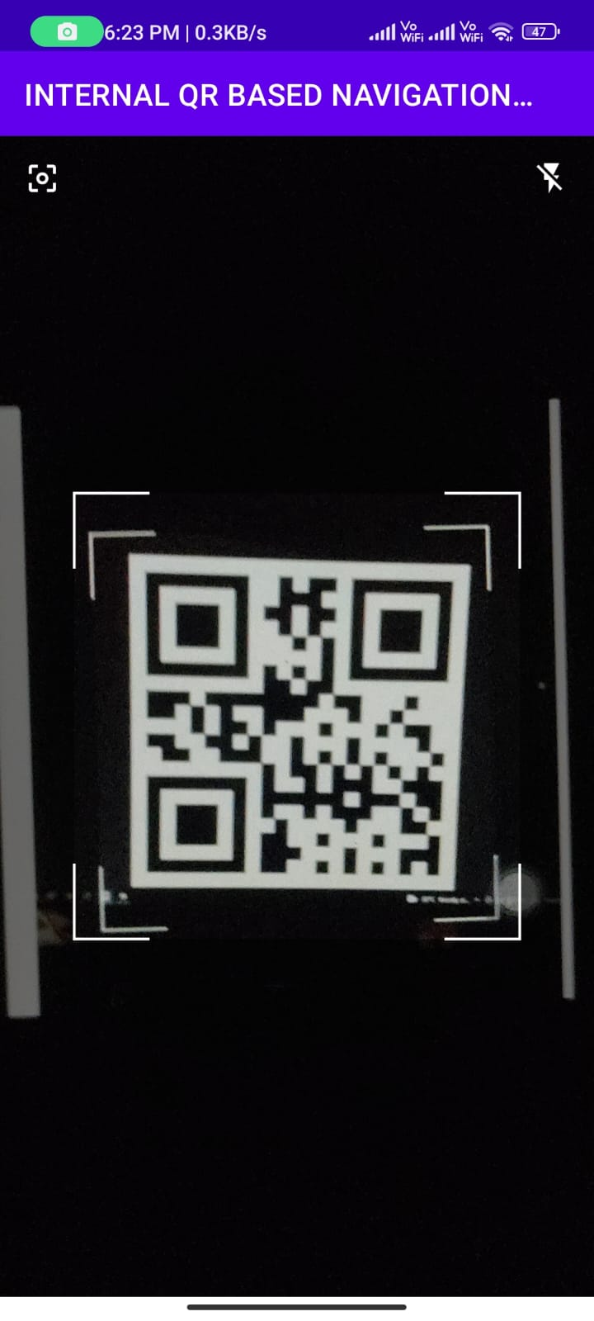

Screenshot 5.1 user scanning the QR code

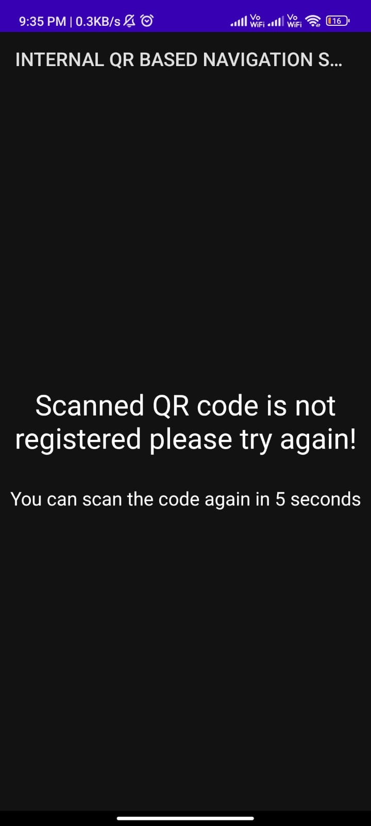

Screenshot 5.2 This page will be shown if the user had scanned a QR code which is not registered.

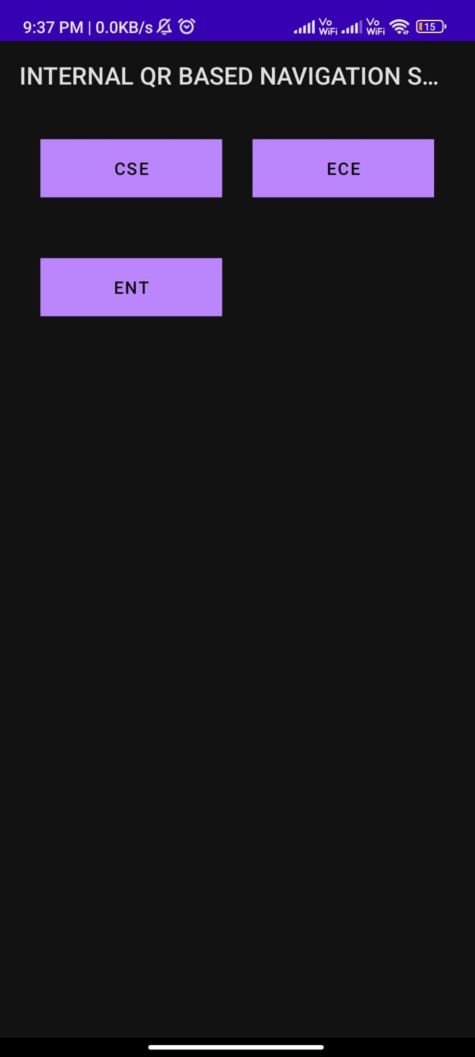

Screenshot 5.3 categories displayed to the user for registered qr.

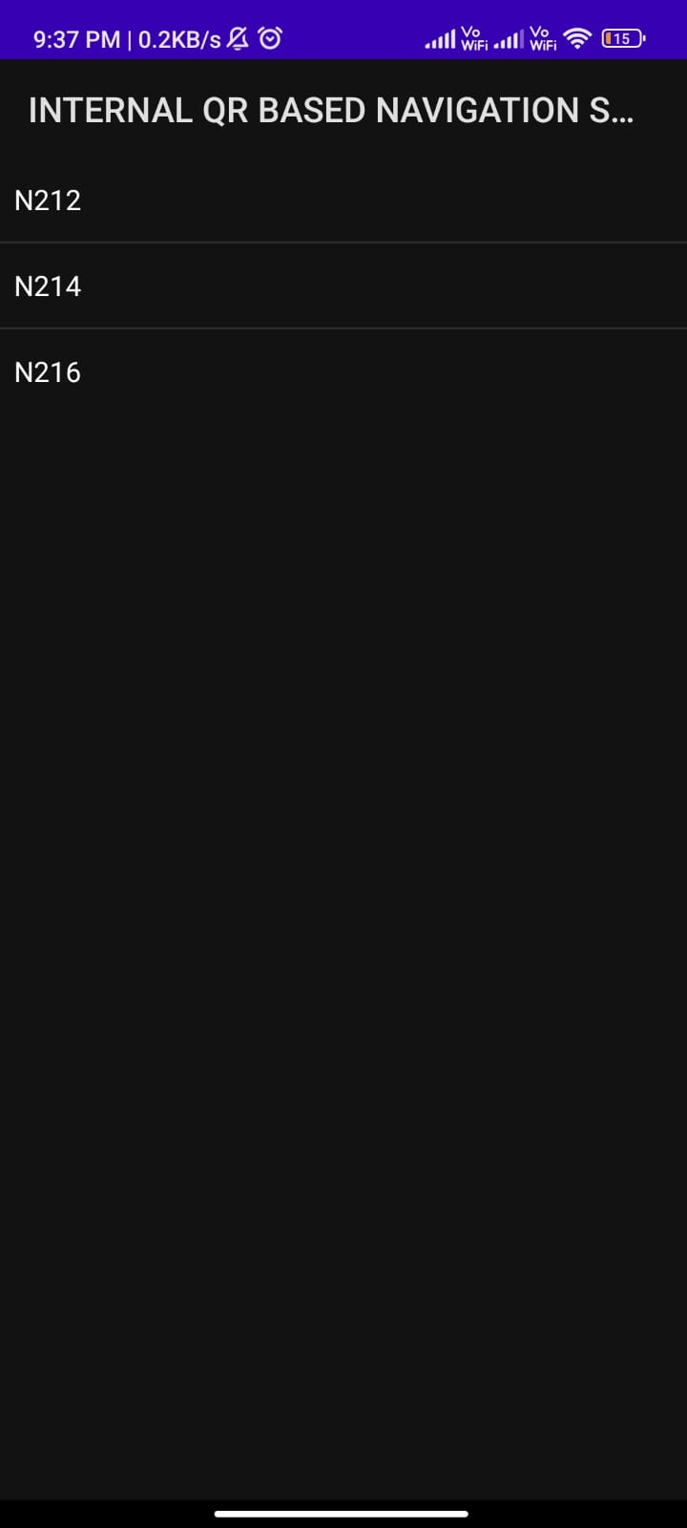

Screenshot 5.4 List of destinations under the selected category CSE

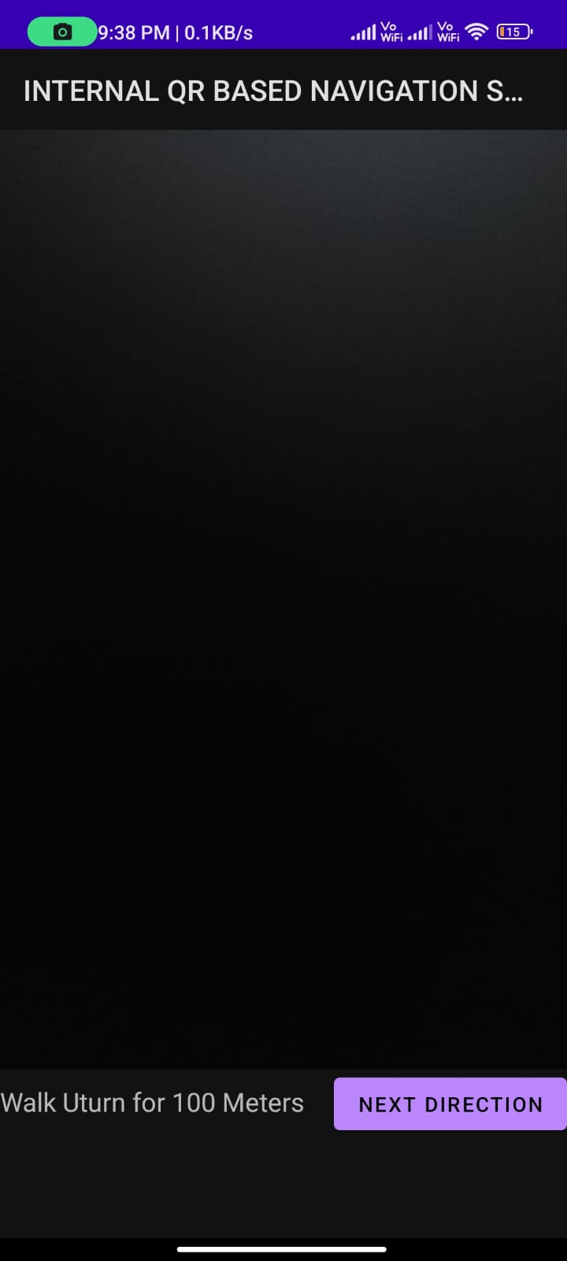

Screenshot 5.5 Application showing directions to the user.

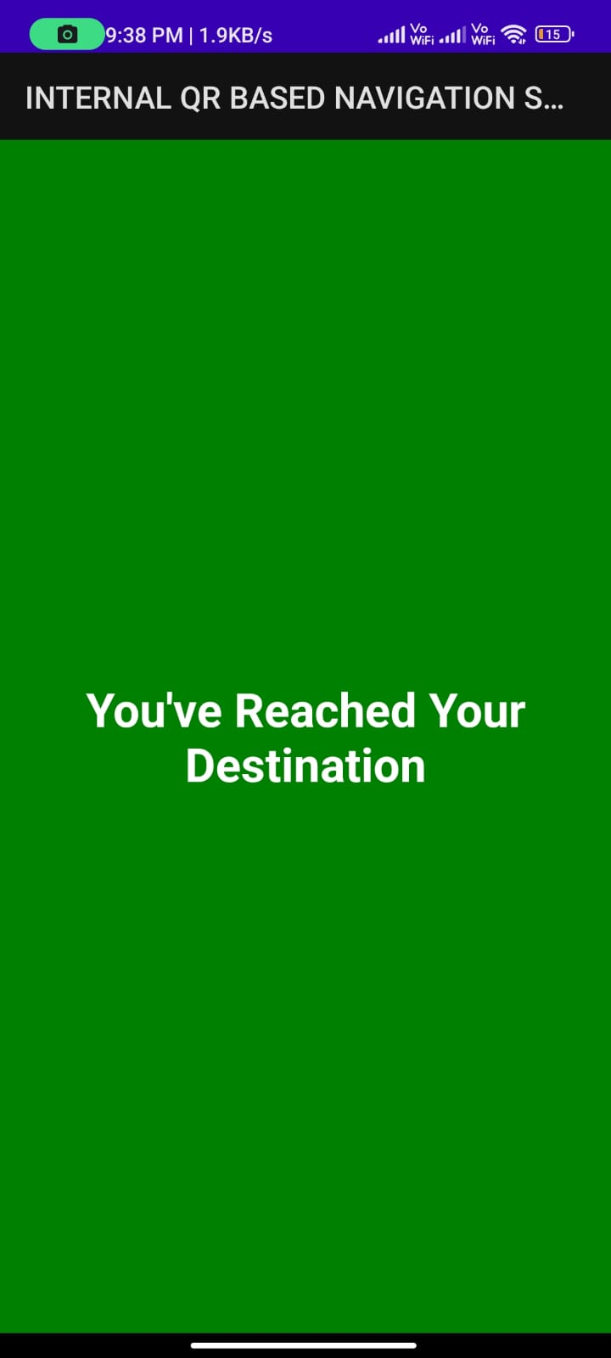

Screenshot 5.6 This page will be displayed if the user had reached the destination.

## 6.TESTING

#### 6.TESTING

##### 6.1 INTRODUCTION TO TESTING

The purpose of testing is to discover errors. Testing is the process of trying to discover every conceivable fault or weakness in a work product. It provides a way to check the functionality of components, subassemblies, assemblies and/or a finished product. It is the process of exercising software with the intent of ensuring that the Software system meets its requirements and user expectations and does not fail in an unacceptable manner. There are various types of tests. Each test type addresses a specific testing requirement.

##### 6.2 TYPES OF TESTING

6.2.1 UNIT TESTING

Unit testing involves the design of test cases that validate that the internal program logic is functioning properly, and that program inputs produce valid outputs. All decision branches and internal code flow should be validated. It is the testing of individual software units of the application .It is done after the completion of an individual unit before integration. This is a structural testing that relies on knowledge of its construction and is invasive. Unit tests perform basic tests at component level and test a specific business process, application and/or system configuration. Unit tests ensure that each unique path of a business process performs accurately to the documented specifications and contains clearly defined inputs and expected results.

6.2.2 INTEGRATION TESTING

Integration tests are designed to test integrated software components to determine if they actually run as one program. Integration tests demonstrate that although the components were individually satisfactory, as shown by successfully unit testing, the combination of components is correct and consistent. Integration testing is specifically aimed at exposing the problems that arise from the combination of components.

6.2.3 FUNCTIONAL TESTING

Functional tests provide systematic demonstrations that functions tested are available as specified by the business and technical requirements, system documentation, and user manuals.

Functional testing is centered on the following items:

Valid Input : identified classes of valid input must be accepted.

Invalid Input

: identified classes of invalid input must be rejected.

Functions : identified functions must be exercised.

Output : identified classes of application outputs must be exercised.

Systems/Procedures: interfacing systems or procedures must be invoked. Organization and preparation of functional tests is focused on requirements, key functions, or special test cases.

##### 

##### 6.3 TEST CASES

6.3.1 CLASSIFICATION

|  |  |  |  |  |
| --- | --- | --- | --- | --- |
| Test case ID | Test case name | Purpose | Input | Output |
| 1 | QR Recognition 1(registered) | To detect  QR | The user scans the qr to find the location. | The output is it shows the locations |
| 2 | QR Recognition  2(unregistered) | To detect QR | The user  Scans the qr to find the location. | The output is it shows that the user is not registered. |

**7.CONCLUSION**

##### 7 .CONCLUSION & FUTURE SCOPE

##### 

##### 7.1 PROJECT CONCLUSION

The problem of indoor navigation remains a significant difficulty because there is no generally applicable and commercially accessible navigation system for the internal environment of intelligent buildings, and such systems are not yet a standard part of smartphones. Developing a QR code-based positioning solution is a simple approach to find destinations in large indoor environments.Indoor positioning and navigation systems are becoming increasingly important as building layouts get more complicated and people become more mobile. Most people find simple floor maps difficult to read, and remaking them when the information on them changes is costly. The databases of Indoor Positioning and Navigation applications are simple to maintain. When changes are needed, and almost everyone these days has a smartphone in their pocket. These systems should leverage sensors that are currently found in modern smart phones for high availability.This project shows how an indoor navigation system may be developed using QR-Codes.In comparison to other methods, this appears to be the most cost-effective where the accuracy of the user’s location is ensured. In conclusion user can now easily navigate in indoor environments like shopping malls or college campuses if those indoor environments are registered with our application.

##### 

##### 7.2 FUTURE SCOPE

The main scope of the project is to find the indoor locations.Nowadays indoor positioning and navigation systems are becoming increasingly important as building layouts get complicated to overcome this problem we had developed an android application to find the indoor locations in large buildings,hospitals,shopping malls etc. Indoor navigation systems can go beyond simple directions when implementing other technologies that enhance the passenger and employee airport experience. It is important to utilize indoor navigation in airports as it can increase efficiency and drive foot traffic.

### 8.BIBLIOGRAPHY

##### 8. BIBLIOGRAPHY

##### 

##### 8.1 REFERENCES

##### [1] Kajal Kumbhar3 Nutan Bankar4 Prof. U. A. Mande5 Abhimanyu Gite1, Swapnil Kam-ble2. Indoor navigation system using qr codes. IJMER, 5(3):473–478, 2015.

##### [2] Yuriy Budiyev. Qr code. Github, 2021.

[3] J. Candy. A Mobile Indoor Location-Based GIS Application. 5th International Symposium on Mobile Mapping Technologies, 2007.

[4] P. Banerjee H. Liu, H. Darabi and J. Liu. Survey of wireless Indoor Positioning Techniques and Systems. IEEE Transactions on Systems, Man, and Cybernetics, Part C (Applications and Reviews), vol. 37, no. 6, pp. 1067–1080, 2007.

[5] Erdelyi J. Ilkoviov ´ a,´ d. and A. Kop ˇ aik. Positioning in indoor environment using qr codes. In Positioning in Indoor Environment using QR Codes, page 6. Fignet, 2014.

[6] Sung Hyun Jang. A qr code-based indoor navigation systemusing augmented reality.

2012.

[7] Agarwal S. Nath A. Sarkar, A. Li-Fi technology: data transmission through visible. In-

ternational Journal of Advance Research in Computer Science and Management Studies,

2016.

[8] Adam Satan. Bluetooth-based indoor navigation mobile system. Research Gate, 1(1):7,

2018.

[9] P.M. Rubesh Anand Sujith Suresh and D. Sahaya Lenin. A Novel Method for Indoor

Navigation Using QR Codes. International Journal of Applied Engineering Research,

2015.

[10] Toth and S.Adam. Development of bluetooth based indoor positioning application,. In

Third IEEE International Conference on Data Mining Workshop on Frequent Itemset

Mining Implementations, 2018.

##### 

##### 8.2 GITHUB LINK

https://github.com/Gajulasandeep/internal-qr-based-navigation-system